INDUSTRIAL TRAINING REPORT
on
HEALTHCARE DATA ANALYSIS

Submitted in partial fulfilment of the requirement for the award of the degree of
BACHELOR OF TECHNOLOGY
in
COMPUTER SCIENCE AND ENGINEERING (DATA SCIENCE)

Submitted By
ABHINAV TOMAR
University Roll No.: 2300321540003

DEPARTMENT OF CSE (DATA SCIENCE)
ABES ENGINEERING COLLEGE, GHAZIABAD
2026
DECLARATION
I hereby declare that the Industrial Training Report entitled “Healthcare Analysis” is an authentic record of my own work carried out as a requirement of Industrial Training during the period from 5 August 2026 to 16 September 2026, for the award of the degree of Bachelor of Technology (CSE-DS), ABES Engineering College, Ghaziabad.

(Signature of Student)
Abhinav Tomar
University Roll No.: 2300321540003
Date:_______________

Acknowledgement
I would like to express my sincere gratitude to YuvaIntern for providing me with the opportunity to complete my virtual internship as a Healthcare Data Analyst Intern. This internship has given me valuable hands-on experience in strategic data planning, quality assurance, statistical analysis, predictive modeling, and data visualization.
I am deeply thankful to the entire team and mentors at YuvaIntern for designing a comprehensive, industry-relevant curriculum that helped enhance my technical and analytical skill set. . I would also like to thank the faculty of the Department of Computer Science and Engineering (Data Science), ABES Engineering College, Ghaziabad, for their encouragement and for permitting me to undertake this training as part of my academic curriculum.

Abhinav Tomar

About the Company
Yuva Intern is India’s first job simulation internship platform, designed to bridge the gap between theoretical knowledge and real-world job responsibilities. We believe that the most effective way to explore a career is to experience the day-to-day tasks, challenges, and achievements that shape it. By partnering with industry experts, we have created a unique program that brings hands-on experiences right to your doorstep. "Yuva Intern" is led by Prabhjyot Kaur Juneja, Board Advisor at Henry Harvin Education.
Our platform allows you to test-drive different roles in marketing, finance, technology, HR, design, and more—so you can make confident career decisions. We firmly believe in “learning by doing”, which is why every simulation is aligned with actual job descriptions. Whether you’re a student or a career switcher, Yuva Intern helps you gain relevant skills, insights, and confidence to find your professional calling.

- Introduction
Healthcare organizations generate large amounts of data through patient registrations, admissions, medical treatment, insurance processing, billing, medications, and testing. Raw data by itself provides limited value unless it is properly processed and analyzed.
The purpose of this project was therefore not simply to train a machine learning model. The project followed the complete data analytics lifecycle:
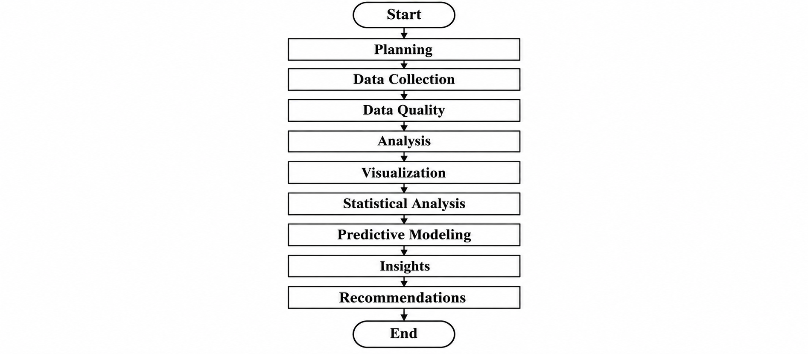
The project was completed in stages over six weeks, with each stage contributing to the next. This final report combines those stages into one integrated narrative rather than treating them as separate activities.
- Task Objective
The main objective of the project is:
To analyze healthcare data, identify important patterns and trends, visualize healthcare information, and evaluate machine learning models to support data-driven healthcare decision-making.

Specific Objectives
- Understand patient demographics.
- Analyze common medical conditions.
- Study hospital admission patterns.
- Analyze healthcare billing amounts.
- Examine test results and medications.
- Create meaningful visualizations.
- Perform statistical analysis.
- Compare machine learning models.
- Generate useful healthcare recommendations.

Resource Required

Software
- Python
- Pandas
- NumPy
- Matplotlib
- Seaborn
- Jupyter Notebook

Hardware
- Laptop/Desktop
- Internet Connection

Strategy Workflow

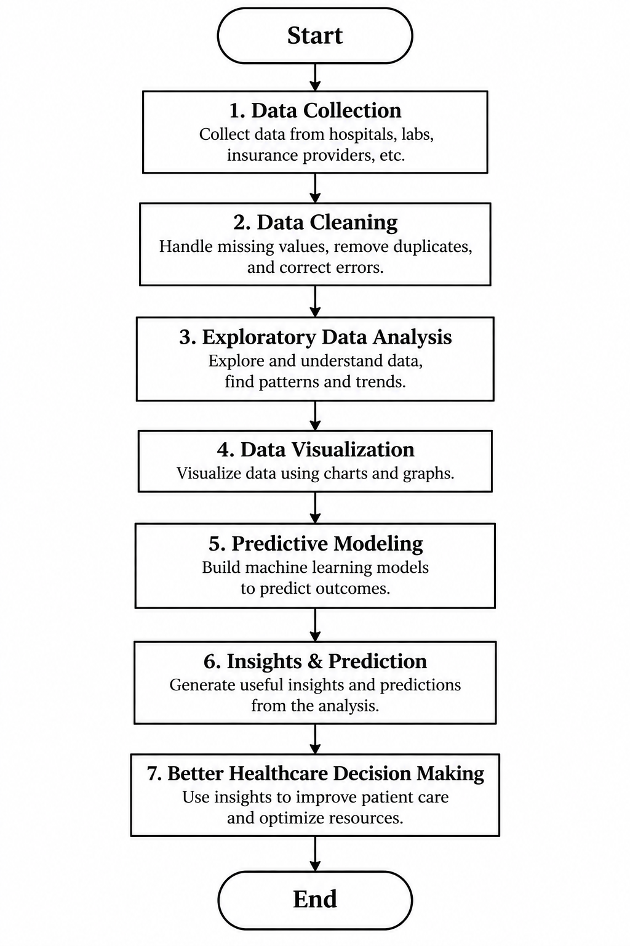

Data Collection Strategy

- Step1: Dataset Selection

A healthcare dataset was selected based on the following criteria:
- Large number of patient records
- Multiple healthcare-related features
- Suitable for data visualization and predictive analysis
- Well-structured and easy to process
- Step2: Data Acquisition

The dataset was downloaded in CSV format and stored on the local computer for further analysis. It was imported into Python using the Pandas library.

- Step3: Data Loading

The dataset was loaded into a jupyter notebook using pandas.

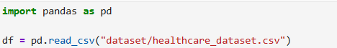

- Step4: Initial Data Inspection
After loading the dataset, the following checks were performed:
- Check the number of rows and columns
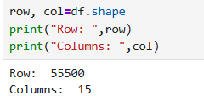
- Verify column names and data types
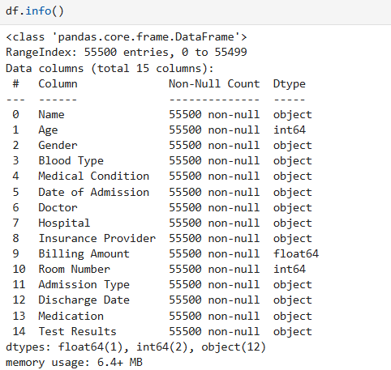
- Review summary statistics
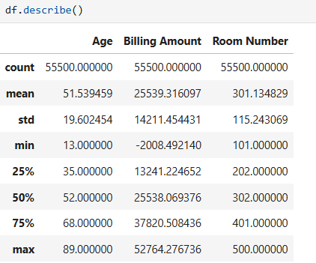

- Step5: Data Validation

The dataset structure was verified by:
- Checking for missing values
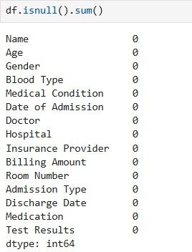
- Identifying duplicate records
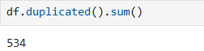
- Ensuring correct data types
There is wrong data types in columns “Data admission, Discharge date” as their data types should be datetime but they are of object.
- Reviewing categorical values for consistency
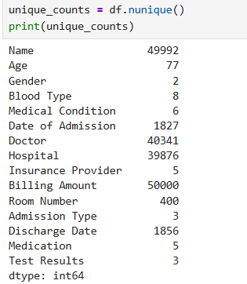
We can see that “Gender”, “Blood type”, “Insurance Provider”, “Admission Type”, “Medication”, “Test Results” are the categorical attributes.

- Step6: Dataset Preparation

Before analysis, the dataset was prepared by:
- Removing duplicate records (if any)
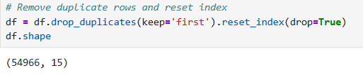
- Handling missing values
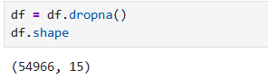
As there is no null values so no change occurs.
- Converting date columns into datetime format
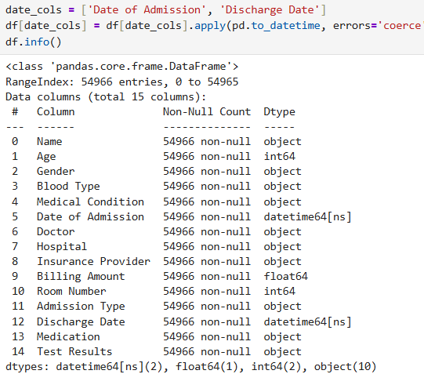
- Validating numerical fields such as Age and Billing Amount
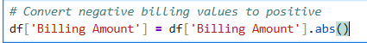

- Step7: Ready For Analysis
After completing these steps, the dataset became ready for:
- Exploratory Data Analysis (EDA)
- Data Visualization
- Statistical Analysis
- Predictive Modeling

Data Quality Assurance

- Step1: Missing Value check

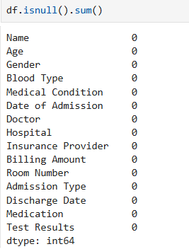

- Step2: Duplicate Record Check

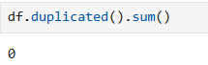

- Step3: Data Type Validation

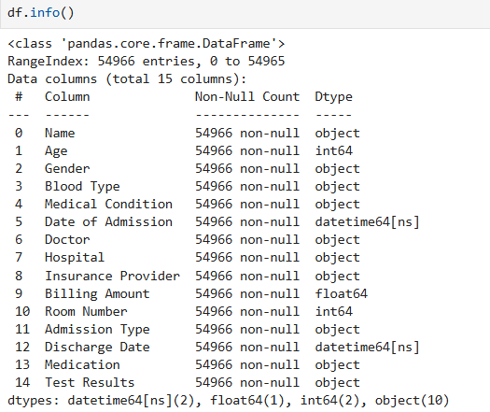
- Step4: Outlier Detection

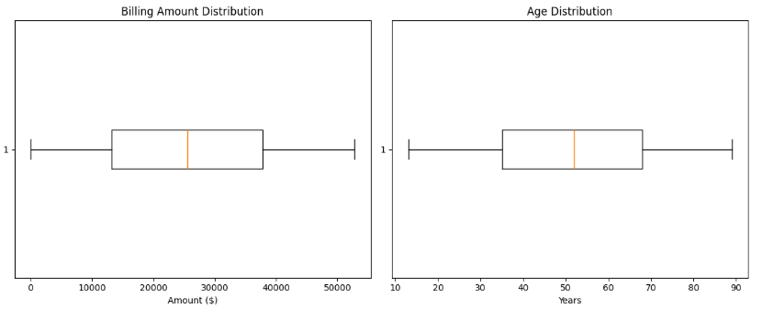
There is no outlier in numerical values

- Dashboard

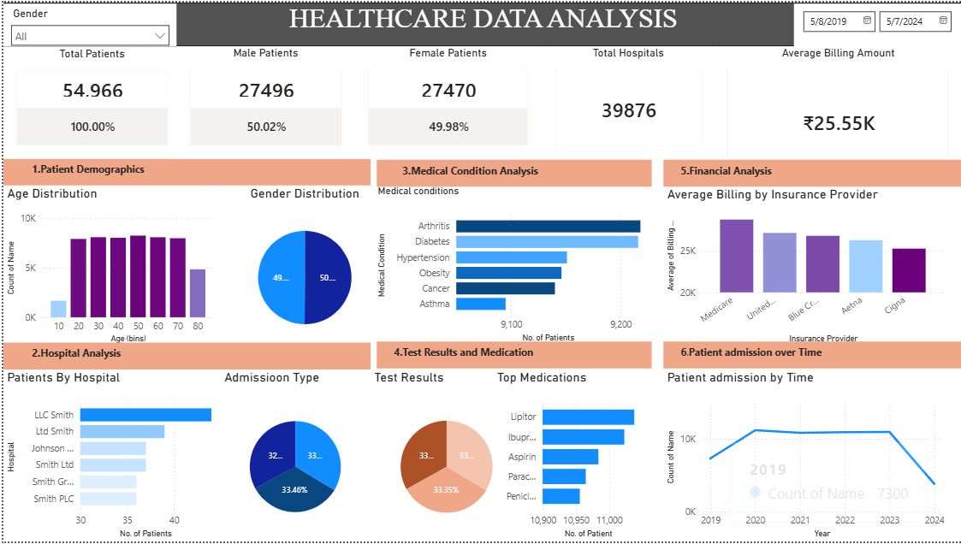

- Insight Communication

The visualizations will help answer questions such as:
- Which age group has the highest number of patients?
50-60 Age group has the highest number of patients.
- Which medical conditions are most common?
Arthritis is the most common medical condition.
- Which hospitals admit the most patients?
LLC Smith hospital admits the most person.
- Which Insurance provider provides the most billing amount?
Medicare Provide the most billing amount
- What percentage of patients have normal test results?
33.3% patients have normal test results.

Descriptive Statistical Analysis

The following statistical measures will be calculated:

Numerical Variables
- Mean
- Median
- Minimum
- Maximum
- Standard Deviation
Applied to:
- Age
- Billing Amount
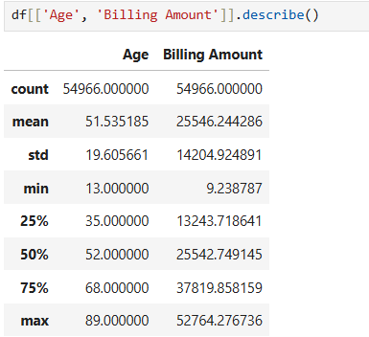

- Frequency Analysis
Frequency analysis will be performed for categorical variables such as:
- Gender
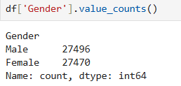
- Medical Condition
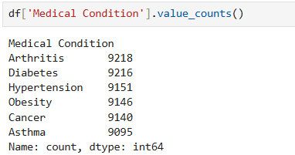
- Admission Type
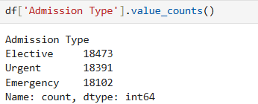
- Blood Type
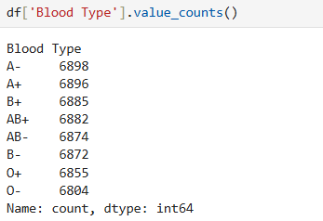
- Test Results
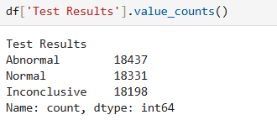
- Correlation Analysis

Relationships between numerical variables will be examined using a correlation matrix.
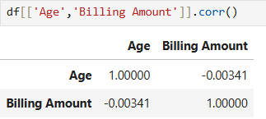

- Predictive Modeling

A simple machine learning model can be developed to predict the Test Results using healthcare features.

Possible Features
- Age
- Gender
- Blood Type
- Medical Condition
- Admission Type
- Billing Amount

Target Variable
- Test Results

Suggested Algorithms
- Decision Tree
- Random Forest
- Logistic Regression

Note: As it is synthetic data accuracy can be very low.

Key Area and Insights from Analysis

The following areas were considered:

Patient Demographics
The age distribution provides an overview of the patient population and helps identify the age groups that contribute most to hospital admissions.
Business/Healthcare implication: Hospitals can use demographic information to plan healthcare resources according to the characteristics of their patient population
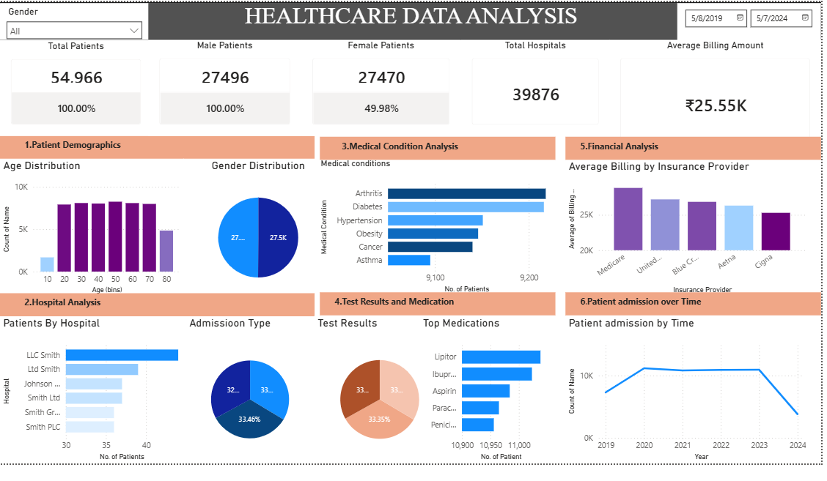.

Medical Conditions
The medical-condition analysis identifies which conditions occur most frequently in the dataset.
Implication: Understanding frequently occurring conditions can help healthcare organizations plan resources such as medical staff, equipment, medicines, and specialized services.

Admission Patterns
The admission analysis compares Emergency, Urgent, and Elective admissions.
Implication: Understanding admission patterns can help hospitals improve staff scheduling, bed allocation, and emergency preparedness.

Billing Amount
The billing analysis shows how healthcare costs are distributed across patients.
Implication: Monitoring billing amounts can help healthcare organizations understand cost patterns and improve financial planning.

Test Results
The dataset contains three test-result categories:
- Abnormal
- Inconclusive
- Normal
The relatively balanced class distribution means that class imbalance is not the main reason for the low model performance.
Implication: Additional clinical variables are likely needed to improve prediction.

- Predictive Modeling Insights

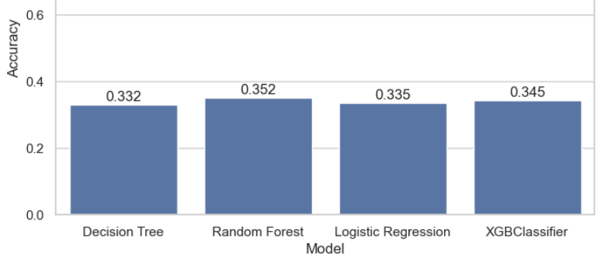

Selected Model: Random Forest
Random Forest was selected because it achieved the highest performance across the tested models.
However, 35.2% accuracy should not be interpreted as a reliable medical prediction system.
The model should be considered a demonstration of predictive analytics rather than a clinical diagnostic tool.

- Recommendations
Based on the project findings, the following recommendations are proposed.

1. Collect More Clinical Data
Future datasets should include features such as:
- Laboratory test values
- Blood pressure
- Heart rate
- BMI
- Medical history
- Disease severity
- Previous diagnoses
These features could provide more useful information for predicting test results.

2. Improve Hospital Resource Planning
Admission patterns can be used to plan:
- Hospital beds
- Medical staff
- Emergency resources
- Medicines and equipment

3. Monitor Healthcare Costs
Billing information can be monitored to identify unusual cost patterns and support better financial planning.

4. Develop Interactive Dashboards
A Power BI dashboard can allow hospital administrators to interactively filter information by:
- Medical condition
- Age
- Gender
- Admission type
- Hospital
- Insurance provider

5. Continue Model Evaluation
Future work should compare additional algorithms such as:
- Gradient Boosting
Note: However, increasing model complexity alone will not solve the problem if the dataset lacks useful predictive features.
- XGBoost
- Support Vector Machine
- K-Nearest Neighbors
- Lessons Learned from Challenges

Several challenges encountered during the project provided useful learning experiences.

Duplicate Records
The initial dataset contained 534 duplicate records. This demonstrated why duplicate detection should be performed before analysis rather than assuming that downloaded data is already clean.

Incorrect Date Types
Admission and discharge dates were initially stored as object variables. Converting them to datetime showed the importance of selecting correct data types before time-based analysis.

Low Model Accuracy
Initially, it could be expected that testing several algorithms would produce a highly accurate model. However, the best result was only 35.2%.
This demonstrated that good algorithms cannot compensate for weak predictive features.

Understanding Negative Results
One of the most valuable lessons was learning that low accuracy is itself a meaningful analytical result. Instead of artificially attempting to report higher accuracy, the correct approach is to investigate why performance is low and report the limitation.

Visualization Selection
Different questions require different visualizations. A histogram is useful for age distribution, while a line chart is more appropriate for time-based admissions. Selecting the correct chart makes findings easier to communicate.

- Project Limitation
The project has several limitations.
The available dataset contains limited detailed clinical measurements. Variables such as laboratory values, vital signs, medical history, and disease severity are not available.
The best predictive model achieved only 35.2% accuracy, so it is not suitable for clinical diagnosis.
The results obtained from this dataset should also not automatically be generalized to all hospitals or real patient populations.
Finally, machine learning predictions should never replace professional medical judgment without extensive validation, appropriate clinical data, and medical oversight.

- Future Scope
Future development can focus on:
- Collecting richer clinical data.
- Adding laboratory and vital-sign information.
- Performing advanced feature engineering.
- Conducting systematic hyperparameter tuning.
- Comparing additional algorithms.
- Using stronger validation methods.
- Developing interactive Power BI dashboards.
- Building real-time healthcare monitoring systems.
- Evaluating models on independent datasets.
- Working with healthcare professionals when defining clinically meaningful prediction problems.
The aim should not simply be to increase accuracy but to create an analysis that is reliable, interpretable, useful, and responsible.

- Conclusion
This project demonstrated the complete process of healthcare data analytics, starting from data collection and quality assurance and continuing through exploratory analysis, visualization, statistical analysis, and predictive modeling.
The healthcare dataset containing 55,500 records and 15 attributes provided sufficient information for performing various types of analysis. Python libraries such as Pandas, NumPy, Matplotlib, and Seaborn were useful for data processing and visualization.
Three machine learning models were compared. Among them, Random Forest achieved the highest accuracy of 35.2%. However, the relatively low accuracy shows that the available features are not sufficient for accurately predicting test results.
Overall, the project demonstrates the importance of combining data analysis, visualization, statistics, and machine learning to extract useful information from healthcare data. The project also highlights the importance of data quality and feature selection when developing predictive models.

